“Gizmo” Charger Switch Installation Guide

The ThunderStruck “Gizmo” is an electronic switch activated by TSM chargers.
This device can be used to turn on electronic devices when the charger is plugged in to an AC outlet. The switched voltage can be from an accessory battery or a higher voltage traction pack. The Gizmo is custom built to fit your application base on your system voltage.
The battery switched output can be wired to the input of a low power DCDC converter so that a 12v supply is available for electronic equipment like our EVCC or BMS.
The following diagram shows how the Gizmo is connected to the system.
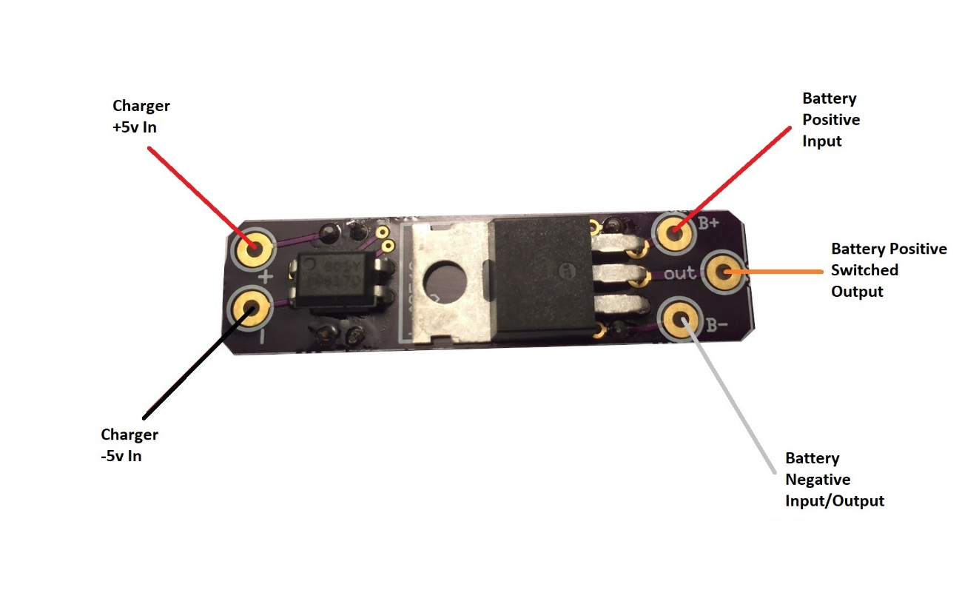
Connection to the Charger
The white connector is provided with the charger. The black connector (right) is installed on the charger harness. Attach the white connector pins so that the “Charger +5v In” lead from the Gizmo connects to the white lead on the charger side.

